

Quantitative Health Sciences/ JJN-3

9500 Euclid Ave, Cleveland, OH 44195

**To:** Candece Gladson **Date:** September 12, 2019

Graham Buchanan

Cancer Biology

**From:** Amy Nowacki **Re: Bev vs. Placebo – nuclear positivity EGR1 & ILF3**

**__________________________________________________________________________________________________**

We have measured the protein expression of EGR1 and ILF3 nuclear expression in the five poor responder mouse xenograft tumors when the mice were treated with either Avastin or placebo.  The five poor responder tumors in mice were from two different GBM patient tumors (G64 and G108).  We have seven fields measured on each mouse tumor for the EGR1 and ILF3 proteins, and we have determined the approximate percentage of tumor cell nuclei that are negative in expression, have weak expression, have 1+ (strong expression), or have 2+ (very strong expression) in each of the seven fields of tumor.  Our outcome will be the percentage of tumor nuclei that are 1+ or 2+ in expression for both EGR1 and ILF3.

1. Is there an increase in the percent of nuclei with positivity for EGR1 in the poor responder mice that were treated with bevacizumab versus placebo?
2. Is there an increase in the percent of nuclei with positivity for ILF3 in the poor responder mice that were treated with bevacizumab versus placebo?

**Our outcome is numeric (% of nuclei with positivity for either EGR1 or ILF3), thus we consider a linear model.**

**We want to compare bevacizumab vs. placebo treated mice tumors.**

**However, we do not have independence; we have 2 GBM xenograft tumors from different patients with each injected and propagated in 4-6 mice resulting in a total of 10 mouse tumors with 7 measures on each.**

**To take the dependence (clustering) into account, we turn to a linear mixed model.**

**Linear mixed model (assuming compound symmetry):**

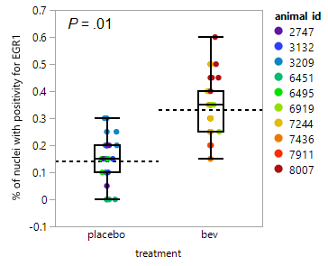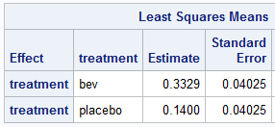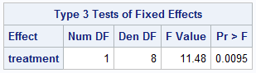

There is a significant increase in the percent of nuclei with positivity for EGR1 in the poor responder mice that were treated with bevacizumab versus placebo (mean 33% vs. 14% respectively, *P* = .01).

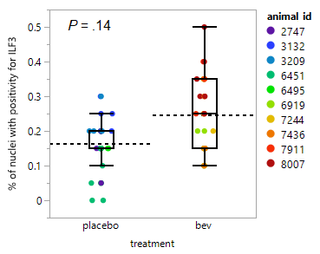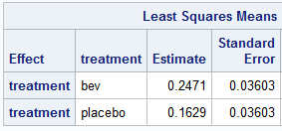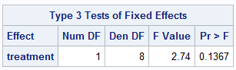

There is insufficient evidence to claim that the percent of nuclei with positivity for ILF3 in the poor responder mice that were treated with bevacizumab differ from those treated with placebo (mean 25% vs. 16% respectively, *P* = .14).